**CAMPUSIQ Project Report**

**TEAM: TITANS**

**Executive Summary**

CAMPUSIQ is an AI-driven Enterprise Resource Planning (ERP) system tailored for educational institutions. It revolutionizes the academic experience by integrating adaptive learning, intelligent scheduling, automated grading, and advanced analytics into a unified platform. By leveraging state-of-the-art artificial intelligence and modern software engineering practices, CAMPUSIQ addresses the challenges of personalized education, administrative overhead, research efficiency, and data utilization. This report details the system’s architecture, core functionalities, technology stack, implementation methodology, and a forward-looking development roadmap.

**Table of Contents**

1. [Introduction](https://chatgpt.com/c/67e8307a-7ebc-800e-b239-3a694aa3fa85#introduction)
2. [Project Vision and Objectives](https://chatgpt.com/c/67e8307a-7ebc-800e-b239-3a694aa3fa85#project-vision-and-objectives)
3. [Market Analysis](https://chatgpt.com/c/67e8307a-7ebc-800e-b239-3a694aa3fa85#market-analysis)
4. [System Architecture](https://chatgpt.com/c/67e8307a-7ebc-800e-b239-3a694aa3fa85#system-architecture)
5. [Key Features and Functionality](https://chatgpt.com/c/67e8307a-7ebc-800e-b239-3a694aa3fa85#key-features-and-functionality)
6. [Technology Stack](https://chatgpt.com/c/67e8307a-7ebc-800e-b239-3a694aa3fa85#technology-stack)
7. [Implementation Details](https://chatgpt.com/c/67e8307a-7ebc-800e-b239-3a694aa3fa85#implementation-details)
8. [User Experience Design](https://chatgpt.com/c/67e8307a-7ebc-800e-b239-3a694aa3fa85#user-experience-design)
9. [Deployment Strategy](https://chatgpt.com/c/67e8307a-7ebc-800e-b239-3a694aa3fa85#deployment-strategy)
10. [Performance Metrics](https://chatgpt.com/c/67e8307a-7ebc-800e-b239-3a694aa3fa85#performance-metrics)
11. [Future Development Roadmap](https://chatgpt.com/c/67e8307a-7ebc-800e-b239-3a694aa3fa85#future-development-roadmap)
12. [Conclusion](https://chatgpt.com/c/67e8307a-7ebc-800e-b239-3a694aa3fa85#conclusion)
13. [Appendices](https://chatgpt.com/c/67e8307a-7ebc-800e-b239-3a694aa3fa85#appendices)

**3. Introduction**

**Background**

* Legacy Systems and Disconnected Experiences:  
  Traditional educational systems often work in isolation, causing fragmented experiences for students, educators, and administrators.  
  *Deep Explanation:*  
  Older systems typically focus on one aspect of education (like administration) without considering the interactive nature of modern learning. CAMPUSIQ was developed to bridge these gaps, integrating various functionalities into one unified platform.

**Problem Statement**

* Personalization at Scale:  
  Educational institutions struggle to provide individualized learning experiences in a mass education setup.  
  *Deep Explanation:*  
  The challenge is to understand and address the diverse needs of each student. CAMPUSIQ tackles this by using AI to analyze individual learning behaviors and adapt course content accordingly.
* Administrative Overhead:  
  Manual handling of scheduling, grading, and attendance consumes significant time and resources.  
  *Deep Explanation:*  
  By automating these processes, the system minimizes the potential for errors, speeds up operations, and reallocates resources towards enhancing the educational experience.
* Research Efficiency:  
  With the ever-increasing volume of academic literature, navigating and synthesizing information is a daunting task.  
  *Deep Explanation:*  
  The AI-driven research tools in CAMPUSIQ help filter, rank, and summarize academic resources, thereby accelerating the research process and reducing information overload.
* Data Utilization and Engagement:  
  Institutions often struggle to turn raw educational data into actionable insights while simultaneously ensuring student engagement.  
  *Deep Explanation:*  
  CAMPUSIQ’s advanced analytics convert data into strategic insights, enabling proactive measures to improve learning outcomes and increase student retention**.**

**4. Project Vision and Objectives**

**Vision Statement**

* "Empowering Students. Inspiring Faculty. Revolutionizing Academia.":  
  This encapsulates the project’s aim to create an ecosystem where both learners and educators benefit from AI-driven enhancements.  
  *Deep Explanation:*  
  The vision highlights a holistic approach: empowering students with personalized learning paths, enabling educators with efficient tools, and transforming academic operations into streamlined, data-informed processes.

**Strategic Objectives**

* Transform Learning Experiences:  
  Develop adaptive learning modules that customize educational journeys based on individual performance and learning patterns.  
  *Deep Explanation:*  
  Utilizing algorithms like collaborative filtering and reinforcement learning, the system continuously refines learning recommendations, ensuring students receive tailored content that addresses their specific challenges and strengths.
* Enhance Faculty Effectiveness:  
  Provide educators with AI tools that reduce time spent on administrative tasks, enabling them to focus on high-impact teaching.  
  *Deep Explanation:*  
  Features such as automated grading and intelligent scheduling free up valuable time, allowing educators to dedicate more time to curriculum development and personalized student engagement.
* Optimize Institutional Operations:  
  Automate and streamline administrative processes to improve overall operational efficiency.  
  *Deep Explanation:*  
  Integration of workflow management, automated notifications, and a centralized data repository ensures that operations are not only more efficient but also more resilient to errors and disruptions.
* Foster Research and Collaboration:  
  Leverage AI to provide tools that aid in literature reviews, research partner matching, and data analysis.  
  *Deep Explanation:*  
  Through semantic search and citation graph analysis, the platform helps researchers quickly locate relevant studies, identify trends, and form strategic collaborations, thereby accelerating academic discovery.
* Drive Data-Informed Decision Making:  
  Implement advanced analytics to convert educational data into actionable insights, supporting continuous improvement across all levels.  
  *Deep Explanation:*  
  Real-time dashboards and predictive analytics allow institutions to monitor performance, identify emerging challenges, and adjust strategies proactively, ensuring sustained academic excellence.

**5. Market Analysis**

**Target Market**

* Higher Education Institutions, Secondary Education, Professional Training Organizations:  
  These segments are targeted because they require advanced systems that can manage complex academic and administrative functions.  
  *Deep Explanation:*  
  Each segment has unique requirements—universities need scalable research tools, high schools require effective classroom management, and professional training organizations demand customizable certification processes. CAMPUSIQ’s modular design addresses these diverse needs through adaptable components.

**Competitive Landscape**

* AI-First Approach:  
  Unlike competitors who retrofit AI into traditional ERP systems, CAMPUSIQ is built from the ground up with AI integration.  
  *Deep Explanation:*  
  By embedding AI into every layer of the system, from scheduling to grading, CAMPUSIQ not only improves accuracy and efficiency but also enables real-time adaptive learning and analytics that older systems cannot match.
* Learning-Centered Design and Comprehensive Integration:  
  The platform focuses on enhancing learning outcomes while ensuring seamless integration between administrative, educational, and research functionalities.  
  *Deep Explanation:*  
  This dual focus ensures that the system does not merely serve as an administrative tool but becomes a catalyst for academic success, bridging the gap between operational efficiency and educational quality.

**Market Trends**

* Personalized Learning and AI Adoption:  
  Increasing demand for tailored educational experiences and growing acceptance of AI in education support the CAMPUSIQ approach.  
  *Deep Explanation:*  
  With the rapid evolution of machine learning and data analytics, educational institutions are more inclined to adopt solutions that promise both personalization and operational improvements. CAMPUSIQ is aligned with these trends, positioning it well for future growth.
* **Remote and Hybrid Learning Models:**The ongoing need for flexible learning environments necessitates robust, scalable systems that can support both in-person and remote interactions.  
  *Deep Explanation:*  
  CAMPUSIQ’s web-based interfaces and mobile applications ensure that users can seamlessly transition between learning environments, maintaining high levels of engagement regardless of location.

**6. System Architecture**

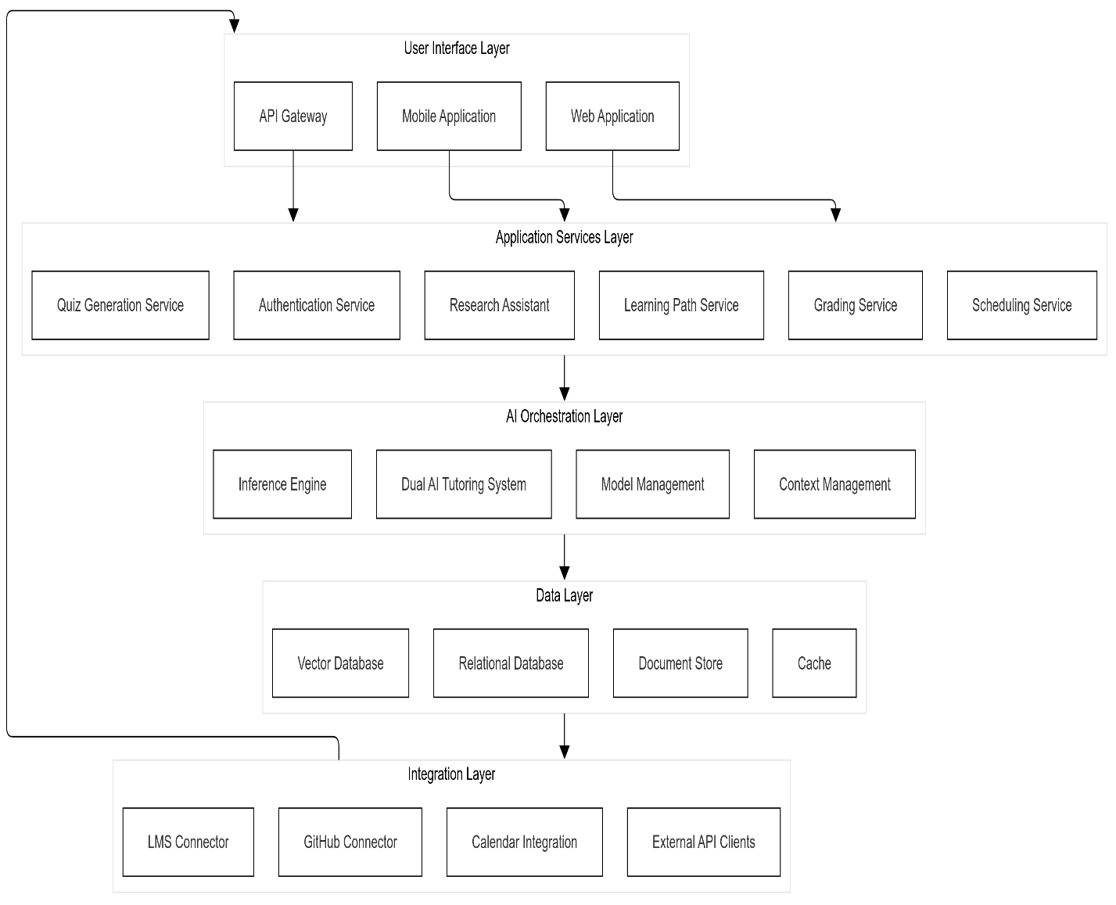

* **Data Flow Architecture’s of Different Components:**

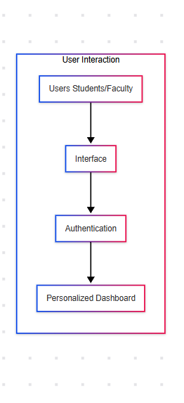

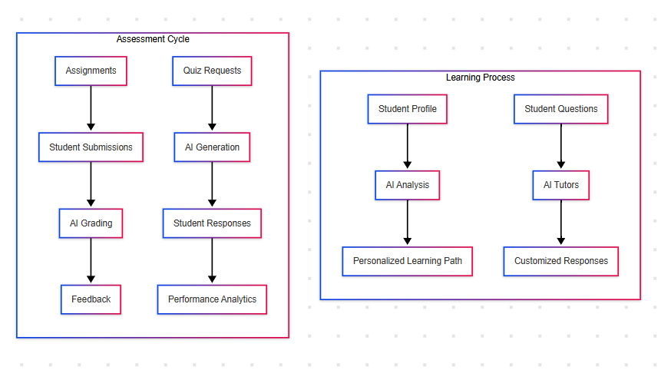

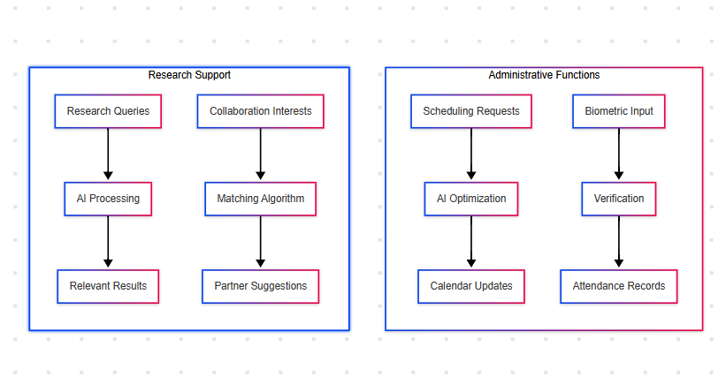

**7. Key Features and Functionality**

**Adaptive Learning Paths**

* AI-Driven Course Recommendations:  
  By analyzing a student’s performance history and learning style, the system recommends courses that best fit the individual’s needs.  
  *Deep Explanation:*  
  This is achieved through collaborative filtering and reinforcement learning algorithms, which continuously refine the recommendations based on real-time performance data and feedback.
* Skill Gap Analysis:  
  Identifies areas where students are struggling and suggests targeted resources to bridge **these gaps.  
  *Deep Explanation:***Using performance metrics and assessment outcomes, the system pinpoints deficiencies and leverages AI to recommend remedial content, ensuring that every student can progress effectively.
* **Progress Tracking and Feedback:**Offers real-time monitoring of student performance, along with predictive insights to forecast future challenges.  
  *Deep Explanation:*  
  Dynamic dashboards display key performance indicators (KPIs) such as course completion rates and assignment quality, allowing students and educators to take corrective action proactively.

**Research Discovery & Collaboration**

* Intelligent Search and Semantic Analysis:  
  Enables nuanced, context-aware search capabilities that go beyond keyword matching to retrieve relevant academic resources.  
  *Deep Explanation:*  
  By applying vector embeddings and natural language processing, the system understands the context behind research queries, delivering more accurate and relevant results.
* **Collaboration Matching:**Connects researchers with complementary skills and interests, fostering interdisciplinary collaborations.  
  *Deep Explanation:*  
  Utilizing graph theory and network analysis, the platform identifies potential research partners and suggests collaborations that can lead to impactful academic contributions**.**
* **Automated Literature Review:**Summarizes large bodies of literature, identifies key themes, and highlights research gaps.  
  *Deep Explanation:*  
  Both extractive and abstractive summarization techniques are used here. This feature not only saves researchers significant time but also ensures that no critical detail is overlooked.

**Intelligent Scheduling Assistant**

* Smart Calendar Management:  
  Automatically schedules academic events, balancing classroom availability, faculty schedules, and student preferences.  
  *Deep Explanation:*  
  Constraint satisfaction algorithms analyze multiple scheduling variables in real time to find the optimal meeting times and resource allocations, minimizing conflicts and maximizing resource utilization.
* **Resource Allocation:**Optimizes the use of classrooms and equipment, ensuring that institutional resources are used efficiently.  
  *Deep Explanation:*  
  By integrating with IoT sensors and resource tracking systems, the scheduling module can dynamically reallocate resources based on real-time usage data.
* **Conflict Resolution:**Proactively identifies scheduling conflicts and offers resolution options before issues impact the user experience.  
  ***Deep Explanation:***Advanced predictive models assess historical data and real-time inputs to flag potential conflicts, enabling administrators to adjust schedules seamlessly.

**AI-Driven Quiz Generation**

* Dynamic Question Generation:  
  Creates quiz questions of varying difficulty levels tailored to the student’s current knowledge state.  
  *Deep Explanation:*  
  Large language models generate contextually appropriate questions while algorithms like item response theory calibrate the difficulty based on the student’s previous responses.
* Adaptive Testing:  
  Modifies the test in real time based on student performance, ensuring that assessments remain challenging yet achievable.  
  *Deep Explanation:*  
  This adaptive mechanism continuously adjusts the question difficulty, providing a personalized testing experience that accurately measures learning progress.
* Comprehensive Explanations:  
  Offers detailed feedback for each question, clarifying the underlying concepts and providing further learning resources.  
  *Deep Explanation:*  
  The system integrates knowledge graphs and contextual data to generate explanations that help students understand mistakes and learn the correct concepts.

**Dual AI Tutors**

* Quick Response Tutor:  
  Provides concise, immediate answers to straightforward queries.  
  *Deep Explanation:*  
  Optimized for speed and efficiency, this tutor employs minimal context prompts to deliver fast responses, ideal for rapid clarification during study sessions.
* Detailed Response Tutor:  
  Offers comprehensive explanations, including examples, diagrams, and code samples where necessary.  
  *Deep Explanation:*  
  By leveraging deeper context windows and advanced prompt engineering, this tutor supports in-depth learning and problem-solving, catering to more complex or nuanced queries.

**AI Assignment Grading**

* Rubric-Based Evaluation:  
  Applies predetermined grading criteria to ensure consistent evaluation across different assignments and courses.  
  *Deep Explanation:*  
  The system uses semantic similarity and natural language understanding to compare student submissions with rubric standards, ensuring fair and objective grading.
* Detailed Feedback Generation:  
  Provides personalized suggestions for improvement, highlighting both strengths and areas needing development.  
  *Deep Explanation:*  
  By analyzing the content of the submission and comparing it with best practices, the system generates actionable insights that can help students improve their understanding and performance.
* Plagiarism Detection:  
  Integrates semantic analysis to flag potential academic integrity issues.  
  *Deep Explanation:*  
  Using a combination of syntactic and semantic similarity measures, the plagiarism module scans submissions against a vast repository of sources, ensuring originality.

**Biometric Attendance System**

* Facial Recognition for Identity Verification:  
  Utilizes convolutional neural networks to accurately identify and verify student identities.  
  *Deep Explanation:*  
  The system processes biometric data in real time and applies liveness detection algorithms to prevent spoofing, ensuring that the recorded attendance is accurate and secure.
* Mobile Check-In and Analytics:  
  Supports remote check-ins via mobile devices, with aggregated data used to analyze attendance patterns.  
  *Deep Explanation:*  
  Data from mobile check-ins is encrypted and stored securely, then analyzed using statistical methods to identify trends and potential issues in attendance patterns.

**Advanced Analytics Dashboard**

* Comprehensive Data Visualization:  
  Integrates data visualization libraries to present complex educational and operational data in an accessible manner.  
  *Deep Explanation:*  
  Interactive dashboards allow administrators, educators, and students to drill down into key metrics, facilitating data-driven decisions. Graphs, heatmaps, and trend lines are all employed to represent data effectively.
* Predictive Modeling:  
  Uses machine learning to forecast student performance, identify at-risk learners, and suggest timely interventions.  
  *Deep Explanation:*  
  Models are trained on historical data and continuously updated with new information, ensuring that predictions remain accurate and relevant.

**GitHub Integration**

* Repository Management and Code Quality Analysis:  
  Automates repository creation, manages assignment submissions, and provides AI-powered code reviews.  
  *Deep Explanation:*  
  Through GitHub’s API, the system streamlines version control and leverages static code analysis to ensure that submitted code meets predefined quality standards. This integration also supports collaborative coding projects and peer reviews.

**8. Technology Stack**

**Backend Technologies**

* Python 3.8+:  
  Chosen for its robust ecosystem and versatility in both web development and AI model implementation.  
  *Deep Explanation:*  
  Python’s extensive libraries and frameworks (such as Flask and TensorFlow) make it an ideal choice for building scalable, maintainable backends that can support complex AI integrations.
* Flask & Flask-RESTful:  
  Provide a lightweight web framework and API structure, making the system flexible and easy to extend.  
  *Deep Explanation:*  
  Flask’s minimalistic design allows developers to integrate only the components needed for the project, resulting in a streamlined and efficient server architecture.

**Database and Caching**

* SQLite for Development / PostgreSQL for Production:  
  The choice ensures rapid prototyping and scalable, robust production deployments.  
  *Deep Explanation:*  
  PostgreSQL’s advanced features such as JSON support and extensive indexing options make it ideal for handling complex data queries in a production environment.
* SQLAlchemy & Alembic:  
  Provide an ORM for database interactions and smooth schema migrations.  
  *Deep Explanation:*  
  These tools abstract away database-specific syntax, enabling developers to focus on business logic rather than low-level SQL, while ensuring that changes to the database schema are tracked and reversible.
* Redis:  
  Used for caching to improve data retrieval speeds and reduce database load.  
  *Deep Explanation:*  
  By caching frequently accessed data, Redis significantly improves response times, which is critical for real-time features like adaptive learning and analytics.

**AI and Machine Learning**

* Groq API with Llama 3 Model:  
  Provides state-of-the-art natural language processing capabilities for generating text, answering questions, and contextual analysis.  
  *Deep Explanation:*  
  The integration of a cutting-edge LLM like Llama 3 ensures that the system can handle a wide range of natural language tasks, from quiz generation to detailed tutoring, with high accuracy.
* TensorFlow/PyTorch:  
  Used for developing and training custom machine learning models, including recommendation systems and computer vision for attendance.  
  *Deep Explanation:*  
  These frameworks offer flexibility and scalability, allowing for experimentation and fine-tuning of models that directly impact learning outcomes and operational efficiency.

**Frontend:**

HTML, CSS, Bootstrap, and JavaScript:  
These technologies ensure that the front-end is lightweight, responsive, and visually engaging.  
Deep Explanation:

* HTML: Provides the semantic structure of your pages.
* CSS (with Bootstrap): Offers a responsive grid system, pre-built components, and styling utilities that ensure cross-device compatibility without the overhead of additional frameworks.
* JavaScript: Adds interactivity and dynamic content manipulation. Vanilla JavaScript is sufficient for most front-end tasks, and it keeps the codebase simple and maintainable.

**9. Implementation Details**

System Components

* AURAPOINT Implementation (Port 8000):  
  This component handles AI model serving, dual tutoring, and natural language query processing.  
  *Deep Explanation:*  
  By segregating AI functionalities into a dedicated service, the system ensures that resource-intensive AI tasks do not interfere with core administrative operations. This separation also facilitates easier updates and scaling of AI services independently.
* Main Application (Port 5000):  
  Manages user authentication, profiles, database interactions, and overall system coordination.  
  *Deep Explanation:*  
  The main application acts as the backbone of the ERP system, integrating various modules and ensuring that data flows seamlessly between the AI layer and traditional operational components.

Database Schema and API Structure

* Normalized Database Design:  
  Key entities such as Users, Courses, Assignments, Learning Activities, and Schedules are structured to minimize redundancy and ensure data integrity.  
  *Deep Explanation:*  
  A normalized schema supports efficient querying and reduces data anomalies, crucial for maintaining the reliability of educational records and performance metrics.
* REST API Endpoints:  
  The API is organized around critical operations like authentication, user management, learning, assessments, scheduling, analytics, and integrations.  
  *Deep Explanation:*  
  This modular API structure allows for clear separation of concerns and easy integration with external systems or mobile applications, while also supporting role-based access control.

AI Model Integration

* Groq API and Custom ML Models:  
  AI models are integrated through both third-party APIs and custom-built solutions, combining the strengths of pre-trained models with specialized fine-tuning for the education domain.  
  *Deep Explanation:*  
  This hybrid approach ensures that while general language understanding is robust, domain-specific tasks (such as curriculum recommendations and plagiarism detection) are handled with specialized models that are continually refined based on institutional data.

10. User Experience Design

User Personas and Interface Design

* User Personas:  
  Detailed profiles for Students, Faculty, Administrators, and Researchers ensure that the system is designed with targeted functionalities for each group.  
  *Deep Explanation:*  
  By understanding the unique workflows and pain points of each user group, the system design can tailor dashboards, notifications, and workflows that maximize productivity and engagement.
* Responsive, Accessible, and Role-Based Dashboards:  
  The interface design emphasizes ease of use, accessibility standards (WCAG 2.1 AA), and personalized dashboards based on user roles.  
  *Deep Explanation:*  
  Consistent navigation, intuitive menus, and clear visual hierarchies ensure that even users with limited technical proficiency can effectively utilize the system. Accessibility considerations ensure that the platform is usable by everyone, including those with disabilities.

User Flows

* Optimized Learning, Grading, Research, and Administrative Processes:  
  Each user flow—from course enrollment to AI-assisted grading—has been meticulously designed to minimize friction and maximize efficiency.  
  *Deep Explanation:*  
  By mapping out each step of a user’s interaction, the design team ensures that the system anticipates user needs, provides timely feedback, and integrates seamlessly with backend processes.

**13. Deployment Strategy(Future Scope)**

Multi-Environment Deployment

* Development, Testing, Staging, and Production Environments:  
  Each environment is tailored for specific stages of the software lifecycle, ensuring that changes are thoroughly vetted before reaching end users.  
  *Deep Explanation:*  
  The use of separate environments minimizes risk by allowing comprehensive testing and performance monitoring in environments that closely mimic production. This staged approach also facilitates smoother rollouts and rollback strategies if issues arise.

Deployment Process and Scaling Strategy

* Containerization with Docker and Orchestration via Kubernetes:  
  Containerized services ensure consistency, while orchestration tools manage scaling and resource allocation dynamically.  
  *Deep Explanation:*  
  Docker images encapsulate all dependencies, making deployments repeatable and reliable. Kubernetes automates load balancing and scaling, ensuring that the system can handle peak loads without degradation in performance.
* Continuous Integration/Continuous Deployment (CI/CD) Pipelines:  
  Automated workflows ensure that every code change is tested, built, and deployed rapidly and reliably.  
  *Deep Explanation:*  
  GitHub Actions automate the entire build and deployment process, reducing human error and speeding up time-to-market for new features and bug fixes.

**14. Performance Metrics**

**Key Performance Indicators (KPIs)**

* System and User Engagement Metrics:  
  Metrics such as average response time, session duration, and feature utilization provide insights into both technical performance and user satisfaction.  
  *Deep Explanation:*  
  Performance monitoring tools track system responsiveness, ensuring that the average response time remains below 200ms while the 99th percentile response time does not exceed one second. User engagement metrics (such as daily active users and average session duration) help gauge the effectiveness of the platform in delivering an engaging educational experience.
* Educational Outcomes and Operational Efficiency:  
  Improvements in course completion rates, timely assignment submissions, and reduced administrative overhead are quantitatively measured.  
  *Deep Explanation:*  
  By comparing historical data against current performance metrics, institutions can validate the impact of CAMPUSIQ on educational outcomes and resource optimization, driving data-informed decision making.

**15. Future Development Roadmap**

**Short-Term Enhancements (0-6 months)**

* Mobile Application Development:  
  Native applications for iOS and Android will be developed, incorporating offline functionality and push notifications to improve accessibility and engagement.  
  *Deep Explanation:*  
  Mobile apps will leverage device-specific features (like local storage and notifications) to ensure seamless learning experiences even when connectivity is intermittent, widening the platform’s reach.
* Enhanced Analytics and Integration Expansion:  
  Further development of predictive analytics and additional LMS connectors will provide deeper insights and more seamless integrations with external educational tools.  
  *Deep Explanation:*  
  By expanding the analytics dashboard and integrating with widely used learning management systems, CAMPUSIQ aims to offer real-time, actionable insights that directly improve educational outcomes and institutional performance.

**Medium-Term Initiatives (6-12 months)**

* Advanced AI Features and Expanded Research Tools:  
  New AI capabilities, including multimodal content generation and research impact prediction, will be introduced to further personalize learning and expedite academic discovery.  
  *Deep Explanation:*  
  The medium-term roadmap focuses on leveraging advancements in AI to create more immersive and interactive learning experiences. Features such as automated video content analysis and grant opportunity matching will empower both students and researchers.
* Enterprise Features and Multi-Institution Support:  
  Customizable dashboards, white-label solutions, and enhanced reporting will cater to the needs of larger educational consortia.  
  *Deep Explanation:*  
  As the system scales, the ability to serve multiple institutions under a unified platform becomes critical. Enterprise features will ensure that CAMPUSIQ can accommodate diverse administrative and academic requirements across different institutions.

**Long-Term Vision (1-2 years)**

* AI Curriculum Design and Virtual Learning Environments:  
  Automated curriculum optimization and immersive, simulation-based assessments will be developed to transform educational content delivery.  
  *Deep Explanation:*  
  In the long term, CAMPUSIQ aims to revolutionize the very structure of educational programs. By using AI to continuously optimize curriculum content based on industry trends and student outcomes, the platform will provide a future-proof educational framework.
* Ecosystem Expansion:  
  Building partnerships with industry, engaging alumni, and supporting lifelong learning initiatives will broaden the impact of CAMPUSIQ beyond traditional academic settings.

**16. Conclusion**

* Enhanced Student Outcomes and Faculty Empowerment:  
  CAMPUSIQ improves educational results through personalized learning, automated grading, and intelligent scheduling, while reducing administrative overhead.  
  *Deep Explanation:*  
  By integrating advanced AI capabilities into every layer of the system, CAMPUSIQ creates a learning environment where both students and educators can thrive. Students receive tailored learning experiences, and educators gain more time for high-value interactions.
* Operational Excellence and Research Acceleration:  
  Streamlined administrative processes and AI-driven research tools ensure that institutions operate efficiently and remain at the forefront of academic innovation.  
  *Deep Explanation:*  
  The combined effect of automation, data-driven insights, and advanced analytics ensures that every aspect of academic operations is optimized, driving both educational excellence and operational resilience**.**

**17. Appendices**

Appendix A: Installation Guide

* System Requirements and Setup:  
  Detailed steps include cloning the repository, installing dependencies, and configuring the environment.  
  *Deep Explanation:*  
  Clear instructions ensure that developers and IT teams can quickly set up the system. This includes creating environment files, configuring databases, and setting up necessary third-party services.

Appendix B: API Documentation

* Endpoint Reference:  
  Comprehensive documentation of REST endpoints provides guidance on authentication, user management, and learning functionalities.  
  *Deep Explanation:*  
  This section serves as a technical reference, enabling developers to integrate, extend, or troubleshoot the system using detailed endpoint specifications, parameter descriptions, and sample responses.

Appendix C: Data Dictionary

* Entity Definitions and Attributes:  
  A detailed description of key data entities ensures consistency in data handling and clarity in system operations.  
  *Deep Explanation:*  
  This document outlines how each piece of data is structured and related, which is critical for developers, database administrators, and data analysts when performing maintenance or developing new features.

Appendix D: User Guides

* Role-Specific Manuals:  
  Tailored guides for students, faculty, and administrators explain system usage in practical terms.  
  *Deep Explanation:*  
  These guides are essential for end-user training, helping different personas understand how to navigate the system, manage tasks, and leverage AI-driven features effectively.